**Indirect Control of Single Acting Cylinder**

Roll no: 2022-MC-58

**Objective:**

To Control the Double Acting Cylinder indirectly.

**Equipment’s and parts:**

* Single acting cylinder
* 3/2 Pneumatic Valve
* Connecting Pipes
* Mechanical push button
* Fluid (Air) Reservoir
* Regulator
* Air distributer (Multi diameter pipes Junction)

**Working Explanation:**

The air goes to the input of 3/2 Pneumatic Valve and is the Input of Push Button. The output of Push Button is connected to 3/2 Pneumatic Valve for its initial starting. When Push Button is pushed, the Valve is Activated and air from Supply pneumatically Pushes the single Acting Cylinder, showing the function of Valve.

**Circuit Diagram**

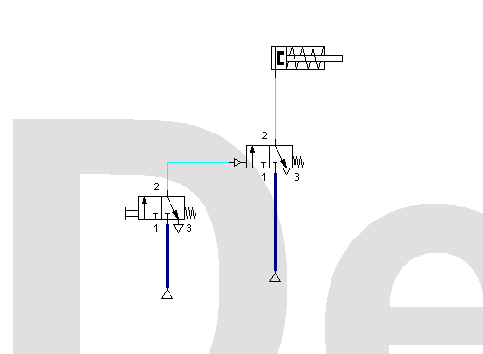

Indirect Control of Single Acting Cylinder

**Conclusion:**

We learned the principle 3/2 Pneumatic valve and its interfacing to drive the single acting cylinder. We indirectly controlled the single acting cylinder to function it through 3/2 valve.